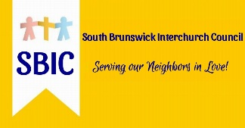

The Lords Pantry is an all-volunteer organization that supplies healthy meals to food local insecure families. Once a week we distribute to each family fresh produce, meat, a bag of healthy store items, along with bread and toiletry items.
On Saturday, October 22nd at 10:00 a.m. The Lords Pantry, a ministry of the South Brunswick Interfaith Council, will be hosting a miniature golf tournament at Tribal Island golf at 901 Highway 17, Little River, SC 29566.
We are inviting local businesses in the area to make their presence be known during this event. You can help by using this as a “team building” event for your employees and fielding a team to come have some fun, provide goody bag stuffers, or advertise your services during the event. It has been proven that when businesses are often recognized acknowledging our efforts, they get more customers.
Sponsor a company team (4 Players) $60.00
Goody Bag stuffers – provide give away items for our goody bags with your name on it!
Banner or sign you supply to put up during our event $50.00
Banner plus team of four (discounted) $100.00

Deadline for sponsorship is October 1st, 2022. For further details, please contact Jim Antunes at oibjimandpeggy@gmail.com or call 910-579-3288. (not a text line).

Thank you in advance for considering helping us feed our food insecure neighbors!

