Brunswick Family Assistance
Christmas Program

Brunswick Family Assistance is gearing up for The Christmas program. BFA will start making appointments for the Christmas Program August 22, 2022. Clients must have proof of all income and expenses for every household member when they call to enroll in the program. The Christmas program is for eligible children (12 years and younger) and seniors (60 and over). The program guarantees two out of three Christmas gift wishes $30.00 or less each and a traditional Christmas dinner. Anyone who wishes to participate in the program should call the Shallotte office at (910) 754-4766, Or Leland Office at (910) 408-1700 to enroll in the program.

Thank You from all of us here at Brunswick Family Assistance

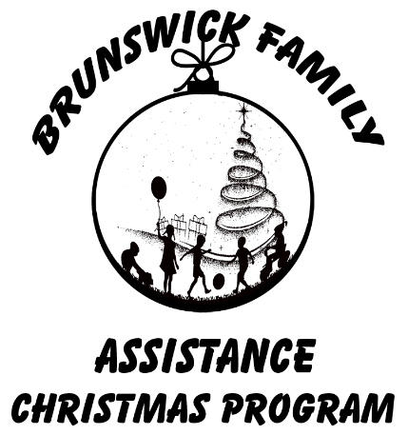

Brunswick Family Assistance Agency will begin making appointments starting August 22, 2022, for the Christmas Basket/Tree of Hope program. The agency will continue to take applications through November 11, 2022. Applicants need to call 754-4766 (Shallotte) and 910-408-1700 (Leland) to receive an appointment time for the enrollment for the Christmas program. To qualify, a household must have income at or below 130% of the Federal Poverty Level. Applicants must provide the following proofs: Income for ALL household members, Brunswick County residency, Social Security/ITIN cards for ALL adults, birth certificates or current Medicaid cards for ALL children aged 12 and under, and all monthly household expenses. The Poverty Level for a family of two is $2,903/monthly, family of 3 is $3,660/monthly, and family of 4 is $4,416/monthly. Qualified applicants will receive gifts for children ages 12 and under and seniors ages 60 and over, plus a food basket with everything needed for a traditional Christmas dinner.
Brunswick Family Assistance is a private nonprofit and partner of Cape Fear Area United Way Agency. The agency also depends on the support of the community through volunteers and donations. If you would like more information or would like to “Adopt” a family or child or decorate a “Tree of Hope,” Please call Amanda at 754-4766 in our Shallotte office, or Beth in Leland office at 910-408-1700 between 9 a.m. and 4:30 p.m. Monday through Thursday and Friday 9-3 pm. If you would like to sponsor a family or child for the Christmas program but you prefer not to go shopping, you may make a monetary donation to sponsor the children and/or seniors of your choice. Brunswick Family Assistance has Board Members that are prepared to do all shopping for the Angel tree tags online. Thank you once again for the support of BFA’s Christmas program and those in our community who otherwise may not have anything on Christmas.
Thank You!
Jeremy Pechin Amanda Johnson Beth Lewis
Program Manager Assistant Program Manager Assistant Program Manager
910-712-3738 910-754-4766 910-408-1700

BRUNSWICK FAMILY ASSISTANCE AGENCY
CHRISTMAS PROGRAM DONOR QUESTIONNAIRE

YES, we would like to help make Christmas merrier for the less fortunate of Brunswick County.

- We will sponsor a Tree of Hope and would like ________ Children’s (age preference _______) tags and ______ Senior tags for our tree. # Of tags
# Of tags

- We will deliver to: _____ Family ________ BFA
- BFA Will need to pick up
- We prefer families from a specific area in the county ________________________
(area)
- We wish to donate $_______ towards the purchase of gifts or turkeys for food baskets.

OTHER/COMMENTS (NEED TAGS BY-Tags will be available between (9/12 till 11/30) _________________
*Unwrapped gifts will need to be dropped off by Dec 2nd, 2022, Thank you!
DATE) _____________________________________

ORGANIZATION/INDIVIDUAL NAME _______________________________________

MAILING ADDRESS ____________________________________________________

____________________________________________________

CONTACT PERSON ____________________________________________________

PHONE ____________________________FAX______________________________
E-Mail _______________________________________________________________
PLEASE RETURN THIS FORM TO: Brunswick Family Assistance
(By 11-28-2022 to participate) P.O. Box 1551
Shallotte, NC 28459

CHRISTMAS DISTRIBUTION IS DEC 12,13,14,15 IF YOUR INTERESTED IN VOLUNTEERING
https://brunswickfamily.volunteerhub.com/

